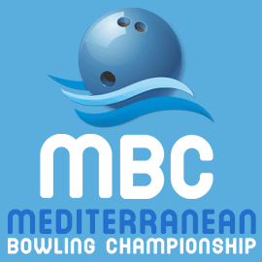
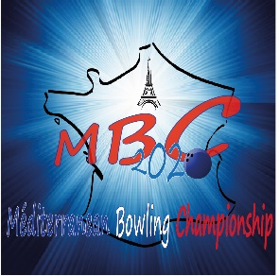
Moussy le Neuf
2020

Form A : Entry Form
Please return this form even if you do not want to participate in the MBC 2020
FEDERATION

We want to participate (yes / no)

The delegation
Number of female players
Number of male players
Number of coaches and officials
Number of guests
Number of press
Total of persons

Federation Contact Information
Contact person
Address
Phone
Mobile
Email
The ultimate deadline of submitting this form is December 15, 2020
Your contact for FFBSQ is Laurence RIOU licence1@ffbsq.org Phone :0033 (0)5 8295 78 62
 | Phone: Béatrice HUNTER | 00 33 (0)6 62323187
https://patrickhunter22.wixsite.com/mbcfrance2020

