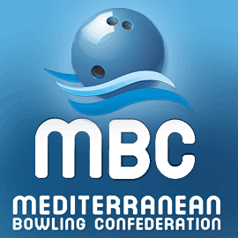
France
Moussy le Neuf 2021

Form A : Entry Form
Please return this form even if you do not want to participate in the MBC 2021
FEDERATION

We want to participate (yes / no)

The delegation
Number of female players
Number of male players
Number of coaches and officials
Number of guests
Number of press
Total of persons

Federation Contact Information
Contact person
Address
Phone
Mobile
Email
The ultimate deadline of submitting this form is July 01, 2021
Your contact for FFBSQ is Laurence RIOU licence1@ffbsq.org Phone :0033 (0)5 8295 78 62
 | Phone: Béatrice HUNTER | 00 33 (0)6 62323187
https://patrickhunter22.wixsite.com/mbcfrance2020

